MINI PROJECT REPORT

**On**

**Shopping Website**

**Submitted by**

**Name of Student Avyakt Pratap Singh**

**Roll No:171500069**

**Name of Student Abhishek Kumar**

**Roll No:171500010**

**Name of Student Krishna Kant Singh**

**Roll No:171500164**

Department of Computer Engineering & Applications

**Institute of Engineering & Technology**

**CERTIFICATE**

I hereby declare that the work which is being presented in the mini project “**Shopping Website”,**in fulfillment of the requirements for viva voce, is an authentic record of our own work carried under the supervision of “**Harvinder Kaur**”

**Department of computer Engineering and Applications**

**GLA University, Mathura**

**17 km. Stone NH#2, Mathura-Delhi Road, P.O. – Chaumuha,**

**Mathura – 281406**



**Declaration**

I hereby declare that the work which is being presented in the mini project “**Shopping Website”,**in partial fulfillment of the requirements for Summer Training viva voce, is an authentic record of our own work carried under the supervision of “**Harvinder Kaur** ”

Signature of Candidate:

Name of Candidate:Abhishek kumar, Avyakt Pratap Singh and Krishna Kant Singh

Roll. No.:171500010,171500069 and 171500164

Course:Bachelor of Technology

Year:3rd

Semester:Sixth

**Abstract**

This mini project report documents the amount of work done in the Mini Project during this semester. The report first shall give an overview of technologies used in making of this project. Then different

Modules of the project with all their description. Report shall also elaborate on the future works which are still to be persuaded as an advancement of current work. I have tried my best to keep the report simple yet technically correct. I hope I succeed in my attempt.

**Acknowledgement**

It is our pleasure to acknowledge the assistance of a number of people without whose help this project would have not been possible.First and Foremost, I would like to express our gratitude to Mrs. Harvinder kaur ma’am project guide, for providing invaluable encouragement, guidance and assistance.

After doing this project we can confidently say that this experience has not only enriched me with technical knowledge but also has unparsed the maturity of thought and vision. The attributes required being a successful professional.

**CONTENT**

**Page No.**

**Certificate .**

**Declaration**

**Abstract**

**Acknowledgement**

**1. Introduction 7**

* 1. **Motivation 7**
  2. **Overview 7**
  3. **Implementation 8**

**2. Overall Description 8**

**2.1 Data Flow Diagram 9**

**2.2 Sequence Diagram 10**

**3. Testing of project 10**

**4. Future Scope 12**

**5. Project Screenshot 12**

**6. Technologies Used 17**

**7. Project Code 24**

**8. Contribution of team members 49**

**9. Bibliography 50**

**1. Introduction**

**1.1 Motivation**

It is difficult for everyone to go out for shopping as everyone is so busy in all other work. This project offers them to buy products of their choice from there home thus saving there lot of time.

**1.2 Overview**

It is difficult for everyone to go out for shopping as everyone is so busy in all other work. This project offers them to buy products of their choice from there home thus saving there lot of time. They don’t need to stand in lines for getting there product. They don’t need to travel from one place to another. There are also some problem with the online shopping such as we are not able to check the quality of the product which is reaching to us.

The project aimed at developing a web application where a user can buy products.The Website involves all the compulsory feature of online shopping website. The major feature of this web application is to help the user to buy the product of their choice where a large number of product are available in the market which makes the user a bit in a confusion. It lists all the type of product and its all relevant information.

**1.3 Implementation and user interface**

Just like every other application, this too has two major parts. The front end and the back end. The Frontend end part relies on HTML and CSS. This is then styled and made to render in the browser. All the relevant information are fetched and are carefully laid on the webpage. The backend is supported by the PHP and database is made by the help of xampp server. All the data is stored in the database from where it is fetched to the user.

**Frontend of website**

When the user first time visits the website he has to create his account by entering his basic details. After that user receive a mail on his registered mail for verification of his details. After verification user can login his account by his/her username and Password. After login user can search for products of his/her choice and add them to his cart and order them.

**Backend of website**

Backend database is managed with the help of the Xampp server and PHP. There are two tables which are stored in the database. One table

Contain all the information of the user and the other table contains the information regarding the user.

**2. Overall description**

**2.1 Data flow diagram**

A **data-flow diagram** (DFD) is a way of representing a flow of a data of a process or a system (usually an information system). The DFD also provides information about the outputs and inputs of each entity and the process itself. A data-flow diagram has no control flow, there are no decision rules and no loops. Specific operations based on the data can be represented by a flowchar**t.**

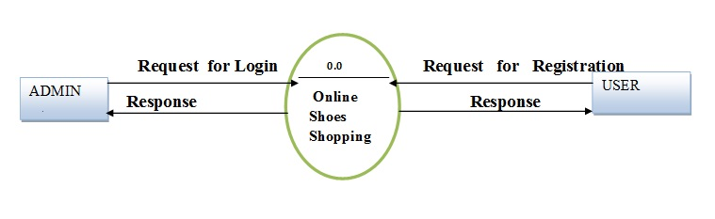

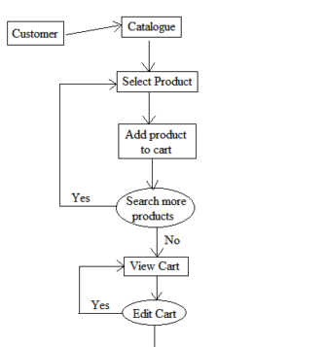

**2.2 Sequence diagram**

A **sequence diagram** simply depicts interaction between objects in a **sequential** order i.e. the order in which these interactions take place. We can also use the terms event **diagrams** or event scenarios to refer to a **sequence diagram**. **Sequence diagrams** describe how and in what order the objects in a system function.

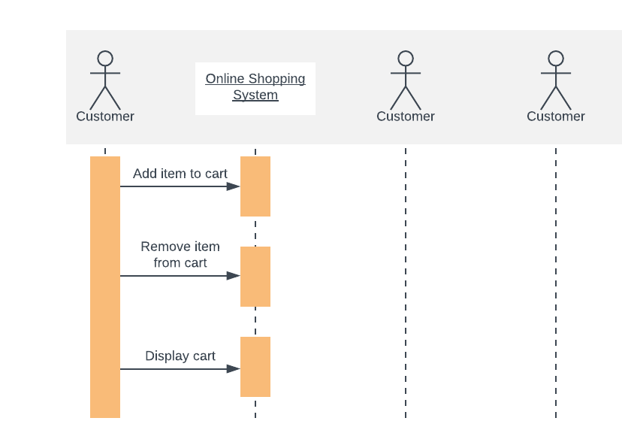

**3.Testing of project**

A project must be tested on all its features. Type of testing a website must go are

* Functional Testing
* Usability Testing
* Security Testing
* Performance Testing
* Database Testing
* Mobile Application Testing(Responsiveness)

Testing must be done on all the pages of the website

**1 Homepage**

We must check that the product on homepage can be clicked for more details.

Product image has a hover or not

Details about project are shown properly

**2. Register Page**

Register Page must be checked with duplicate mail and username.

Correct details are filled on each column.

**3. Login Page**

Login Page must have a testing that unregistered user must not login

Username and password must be associated with same account

**4. Cart**

Cart must check that right product must e added to the cart

Price of the product must be correct.

The product should not be added to the cart without account

Product should not be removed if account is logged out

**5. Database**

Database must have check details or saved on the right table

Database must have received all the detail.

**4. Future Scope of Project**

This project does not contain all the facilities which are provided in the shopping website. The Module which can be added in this project are

1. Payment Module

2 Separate Admin Module

3. More Details about the project

There are many other modules which can be added to this project if this project is taken further

**5. Project Screenshot**

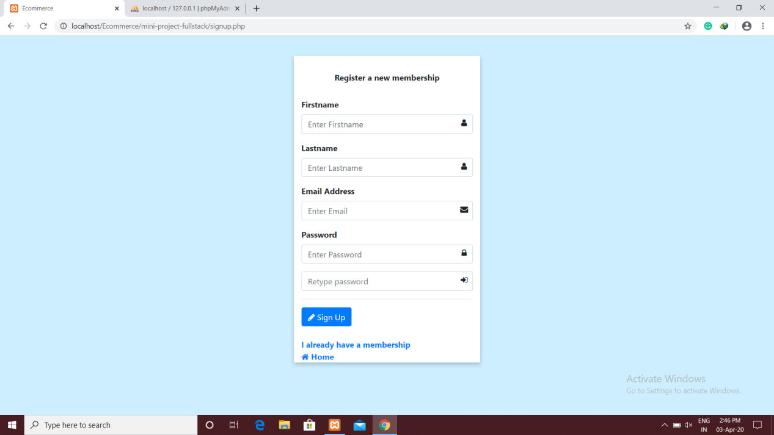

**Register Page**

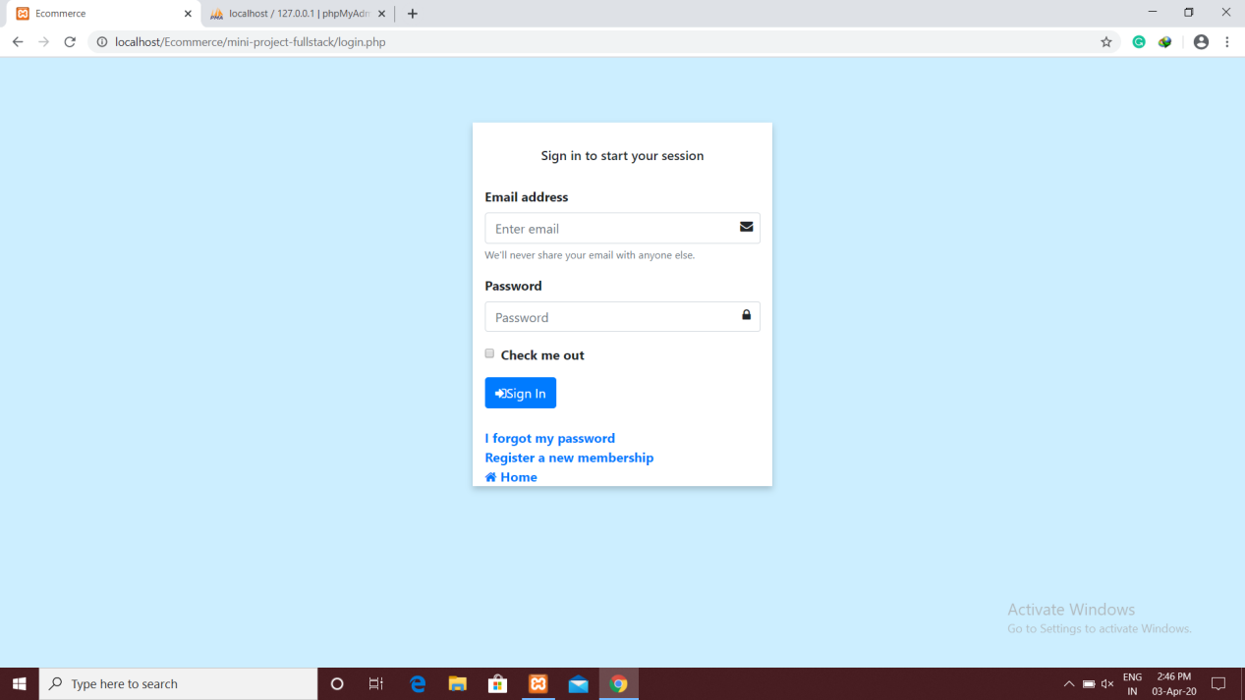 **Login Page**

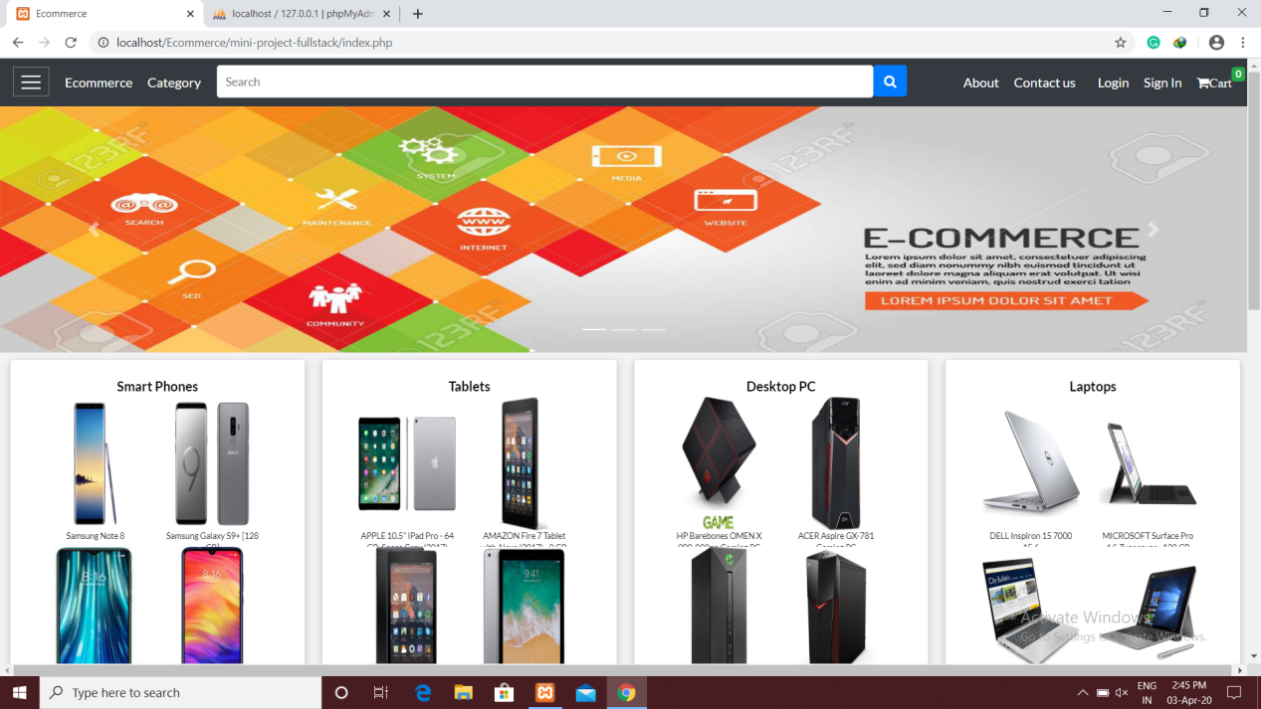

**Homepage**

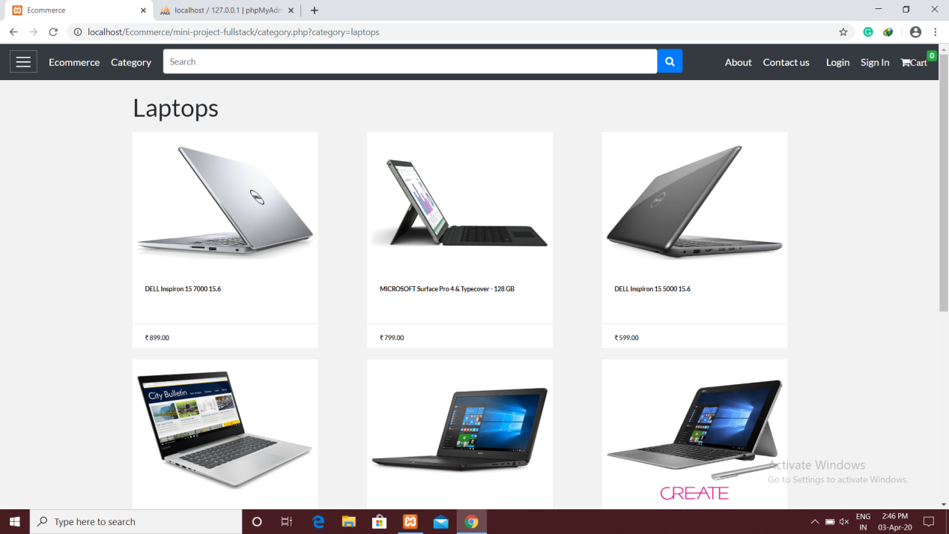

**Category**

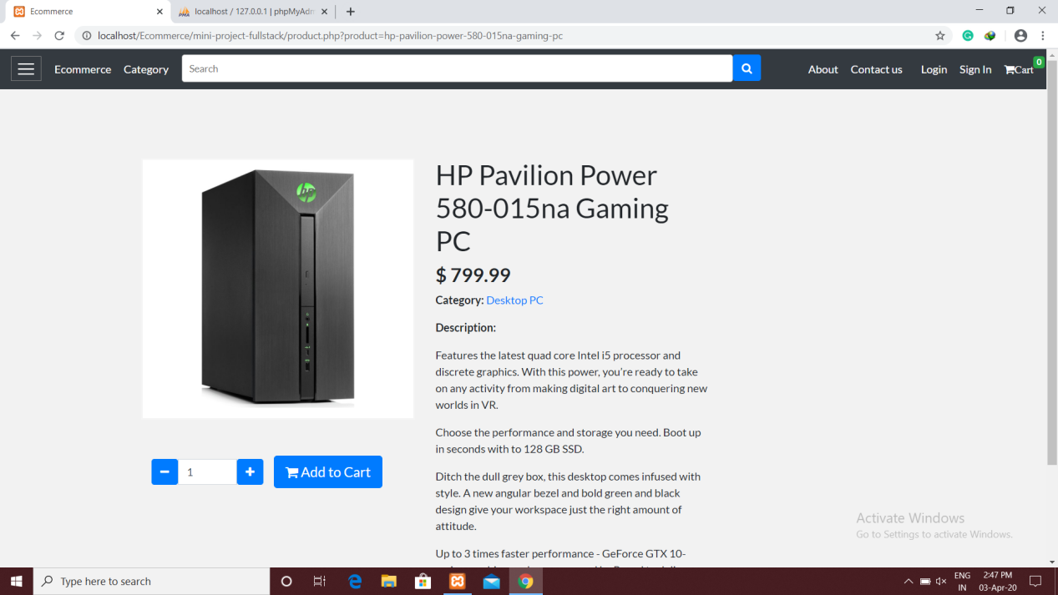

**Product**

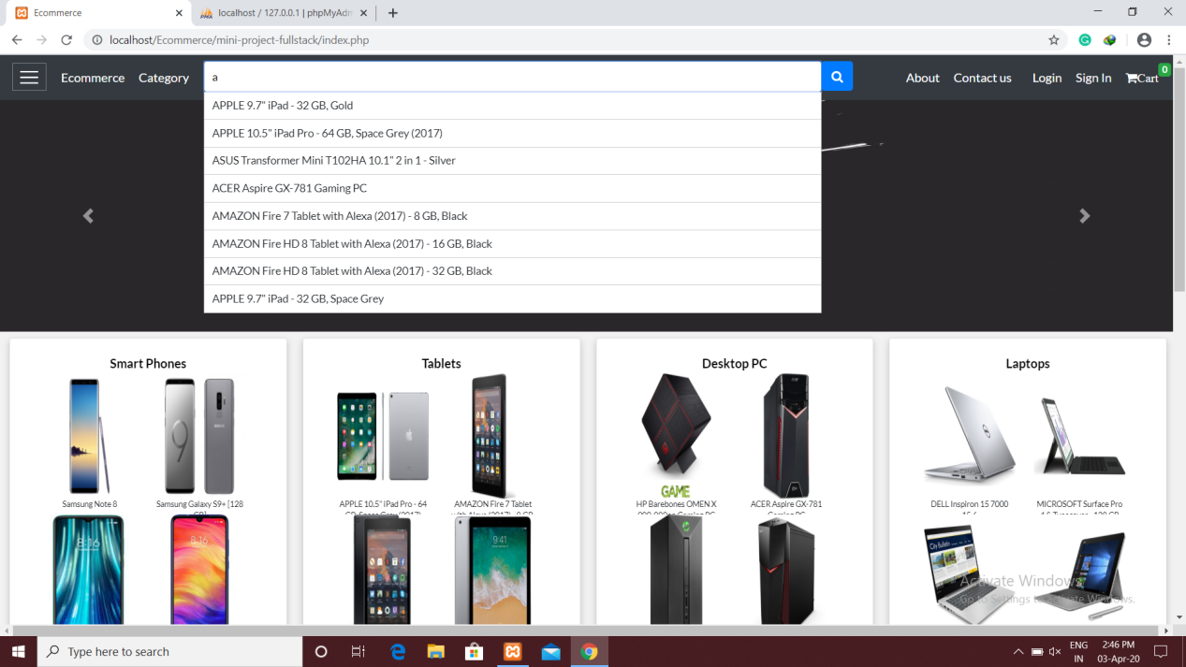

**Live Search**

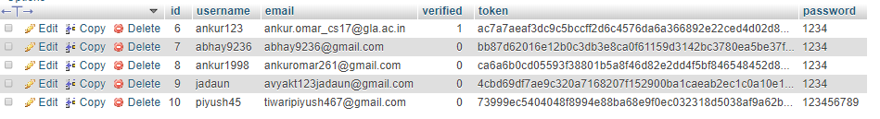

**Users Table**

**6. Technologies Used**

**a) HTML**

Hypertext Markup Language  is the standard markup language for documents designed to be displayed in a web browser. It can be assisted by technologies such as Cascading Style Sheets  and scripting languages such as PHP. Web browsers receive HTML documents from a web server or from local storage and render the documents into multimedia web pages. HTML describes the structure of a web page semantically and originally included cues for the appearance of the document.

HTML markup consists of several key components, including those called tags (and their attributes), character-based data types, character references and entity references. HTML tags most commonly come in pairs like <**h1**> and </**h1**>, although some represent empty elements and so are unpaired, for example <**img**>. The first tag in such a pair is the start tag, and the second is the end tag.

<!DOCTYPE html>  
<html>  
<head>  
<title>Page Title</title>  
</head>  
<body>  
  
<h1>This is a Heading</h1>  
<p>This is a paragraph.</p>  
  
</body>  
</html>

Example of HTML

**b) CSS**

Cascading Style Sheets (CSS) is a style sheet language used for describing the presentation of a document written in a markup language like HTML CSS is a cornerstone technology of the World Wide Web, alongside HTML and JavaScript

CSS is designed to enable the separation of presentation and content, including layout, colors, and fonts. This separation can improve content accessibility, provide more flexibility and control in the specification of presentation characteristics, enable multiple web pages to share formatting by specifying the relevant CSS in a separate .css file, and reduce complexity and repetition in the structural content.

CSS has a simple syntax and uses a number of English keywords to specify the names of various style properties.

A style sheet consists of a list of rules. Each rule or rule-set consists of one or more selectors, and a declaration block.

Example of css code.

body {  
  background-color: lightblue;  
}  
  
h1 {  
  color: white;  
  text-align: center;  
}  
  
p {  
  font-family: verdana;  
  font-size: 20px;  
}

**c) Bootstrap**

Bootstrap is a free and open-source  CSS framework directed at responsive, mobile-first front-end web development. It contains CSS- and (optionally)  JavaScript-based design template fortypography, forms, buttons, navigation and other interface components.

Bootstrap is the third-most-starred project on GitHub, with more than 135,000 stars, behind only freeCodeCamp  (almost 305,000 stars) and marginally behind Vue.js framework

Bootstrap also comes with several JavaScript components in the form of jQuery plugins. They provide additional user interface elements such as dialog boxes, tooltips, and carousels. Each Bootstrap component consists of an HTML structure, CSS declarations, and in some cases accompanying JavaScript code. They also extend the functionality of some existing interface elements, including for example an auto-complete function for input fields.

**Example of Bootstrap Code**

<div class="jumbotron text-center">  
  <h1>My First Bootstrap Page</h1>  
  <p>Resize this responsive page to see the effect!</p>  
</div>  
<div class="container">  
  <div class="row">  
    <div class="col-sm-4">  
      <h3>Column 1</h3>  
      <p>Loremipsum dolor..</p>  
    </div>  
    <div class="col-sm-4">  
      <h3>Column 2</h3>  
      <p>Loremipsum dolor..</p>  
    </div>  
    <div class="col-sm-4">  
      <h3>Column 3</h3>  
      <p>Loremipsum dolor..</p>  
    </div>  
  </div>

**d) PHP**

PHP: Hypertext Preprocessor (or simply **PHP**) is a general-purpose programming language originally designed for web development.

PHP code with html

<!DOCTYPE html>

<html>

<head>

<title>PHP "Hello, World!" program</title>

</head>

<body>

<?php**echo**'<p>Hello, World!</p>';?>

</body>

</html>

Php code without html

<?='Hello world';

The term PHP is an acronym for **PHP: Hypertext Preprocessor**. PHP is a server-side scripting language designed specifically for web development. PHP can be easily embedded in HTML files and HTML codes can also be written in a PHP file. The thing that differentiates PHP with client-side language like HTML is, PHP codes are executed on the server whereas HTML codes are directly rendered on the browser.

**GET and POST Method**

Both GET and POST create an array (e.g. array( key1 => value1, key2 => value2, key3 => value3, ...)). This array holds key/value pairs, where keys are the names of the form controls and values are the input data from the user.Both GET and POST are treated as $_GET and $_POST. These are superglobals, which means that they are always accessible, regardless of scope - and you can access them from any function, class or file without having to do anything special.$_GET is an array of variables passed to the current script via the URL parameters.$_POST is an array of variables passed to the current script via the HTTP POST method.

**e) Xampp Server**

**XAMPP**  is a free and open-source cross-platform web server solution stack package developed by Apache Friends, consisting mainly of the Apache HTTP Server, MySQL database, and interpreters for scripts written in the PHP .Since most actual web server deployments use the same components as XAMPP, It makes transitioning from a local test server to a live server possible.

XAMPP is regularly updated to the latest release of Apache, MariaDB, PHP and Perl. It also comes with a number of other modules including OpenSSL, phpMyAdmin, MediaWiki, Joomla,  and more. Self-contained, multiple instances of XAMPP can exist on a single computer, and any given instance can be copied from one computer to another. XAMPP is offered in both a full and a standard version.

**7. Project Code**

**Login Module code**

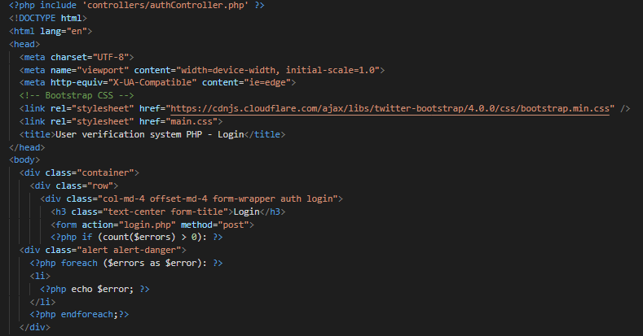

**Figure 1**

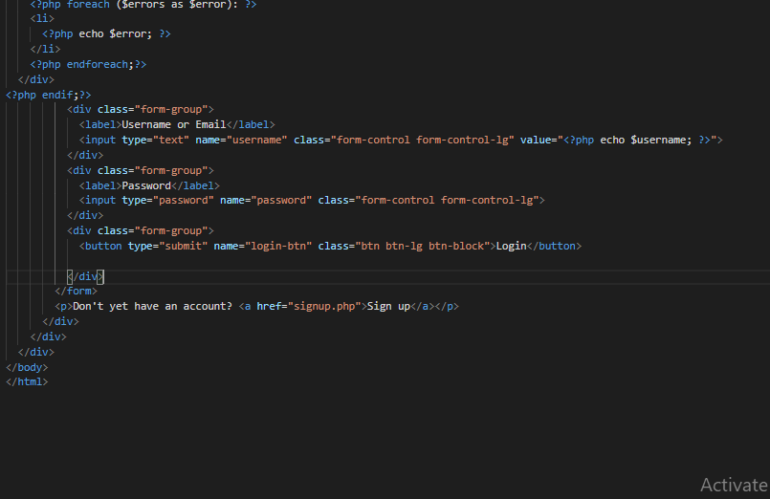

**Figure 2**

**Description**

Login Module led the user to login to his account by his unique username and password . After logging in user can see his previous history and the user can also order something which the user want to order. User can also logout his account after doing his task.

**SignUp Module code**

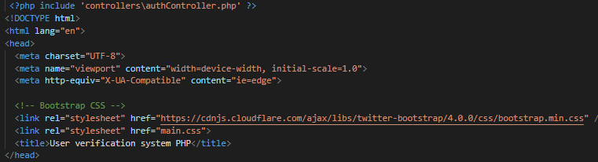

**Figure 3**

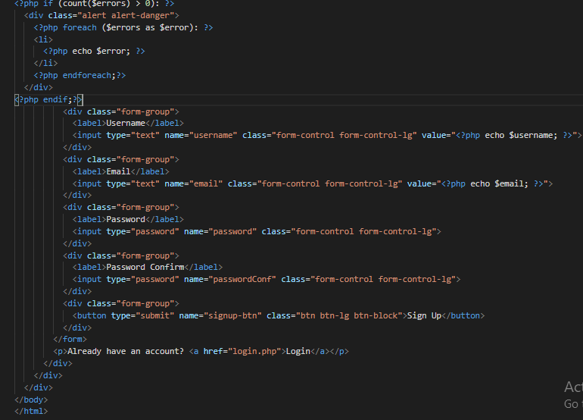

**Figure 4**

**Description**

Signup Module led the user to create his account on the website. You must have an account before you can do anything on this website. For signup you must have a username ,email and a password.

**Logout Module Code**

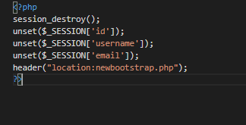

**Figure 5**

**Email verification Code**

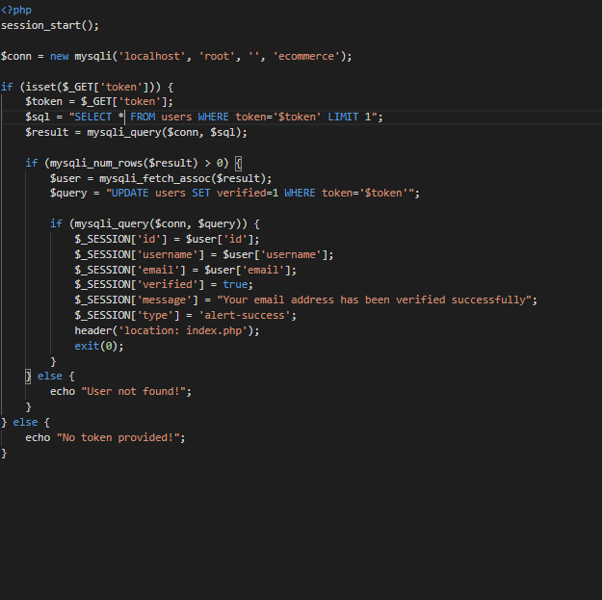

**Figure 6**

**Description**

Email verification module is added for the security purpose so that no other person can use your email for creating his account. This module sends email to the registered email for verification

**Cart Module code**

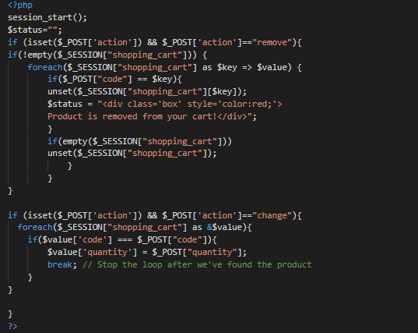

**Figure 7**

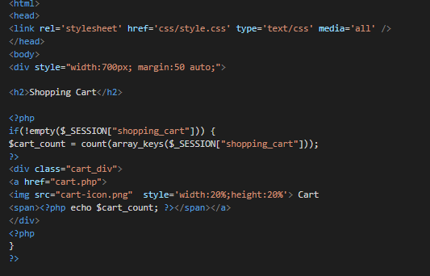

**Figure 8**

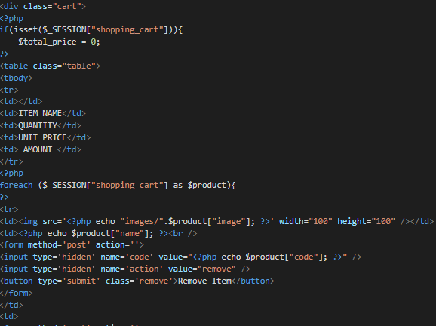

**Figure 9**

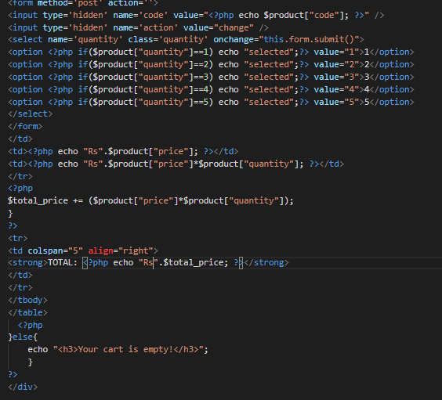

**Figure 10**

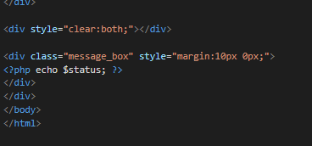

**Figure 11**

**Description**

It is an important module of the project as it help to order the product bought. The user can select the product of there choice and add to the cart for the further processing. The cart has a feature to increase the quantity of each product. In cart we can see the total payment and we can not pay for the product as this website does not have payment module.

**CSS Module Code**

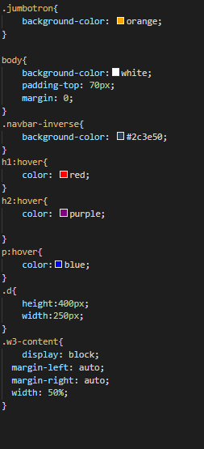

**Figure 12**

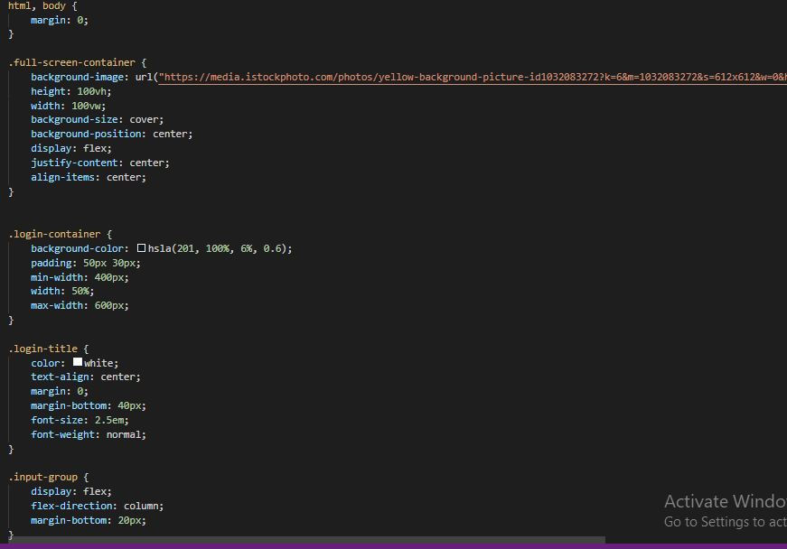

**Figure 13**

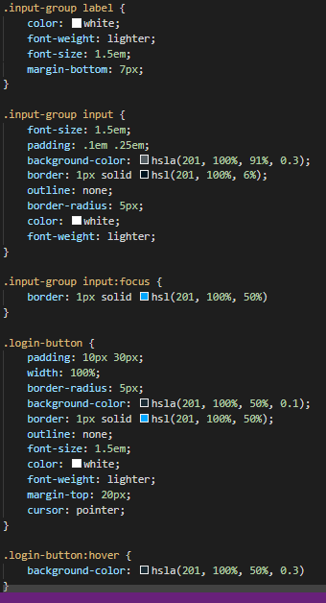

**Figure 14**

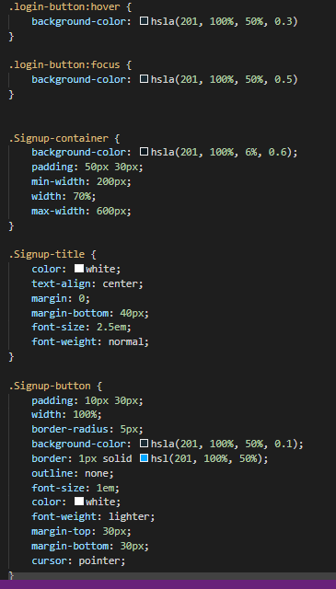

**Figure 15**

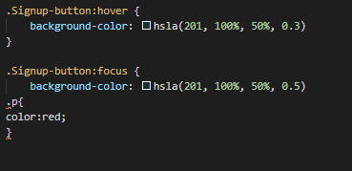

**Figure 16**

**Description**

CSS is designed to enable the separation of presentation and content, including layout, colors, and fonts. This separation can improve content accessibility, provide more flexibility and control in the specification of presentation characteristics, enable multiple web pages to share formatting by specifying the relevant CSS in a separate .css file, and reduce complexity and repetition in the structural content.

Css is Used for the styling of the content.

**Homepage Code**

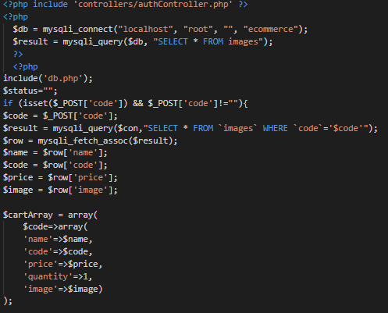

**Figure 17**

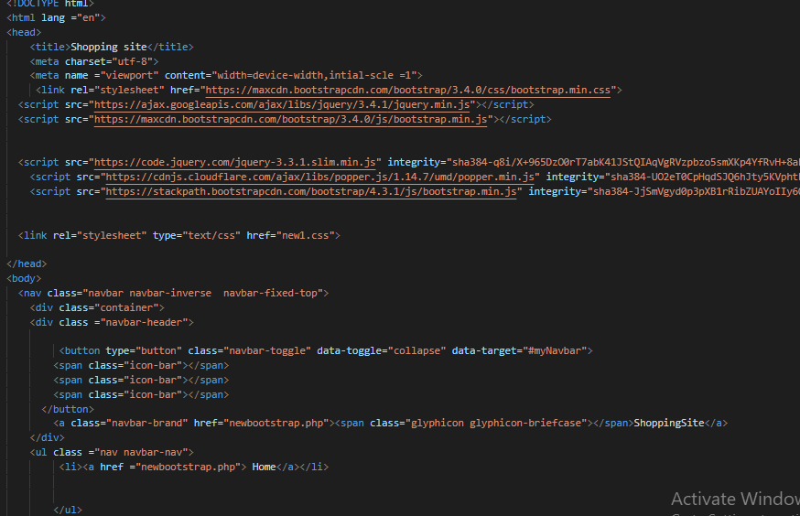

**Figure 18**

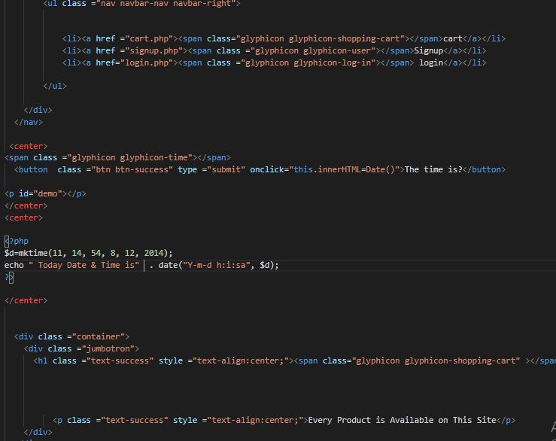

**Figure 19**

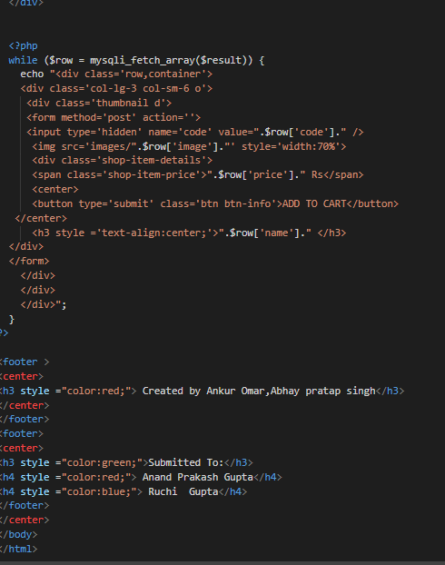

**Figure 20**

**Description**

Homepage is an important part of the website as it is the page which opens when the user opens the website. It has all the important interfaceOf the frontend. All the product are displayed in this page. Different button for different links are provided in this page. From this page we move to cart, login, signup module.Navbar is an important part of the Home page.

**Database Module**

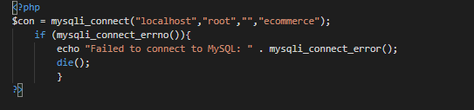

**Figure 21**

**Description**

Database is very important part of project. Database has all the data saved in it. We have used xampp server for creating the database .We have used MySQL for query running.

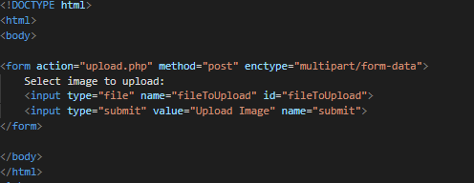

**Figure 22**

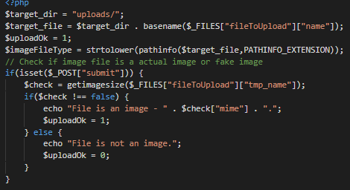

**Figure 23**

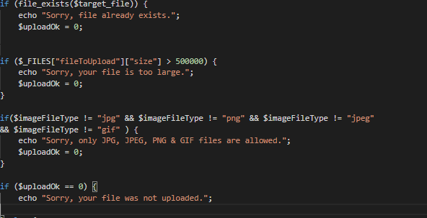

**Figure 24**

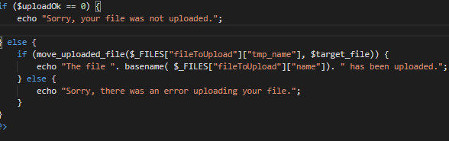

**Figure 22**

**Image Module Code**

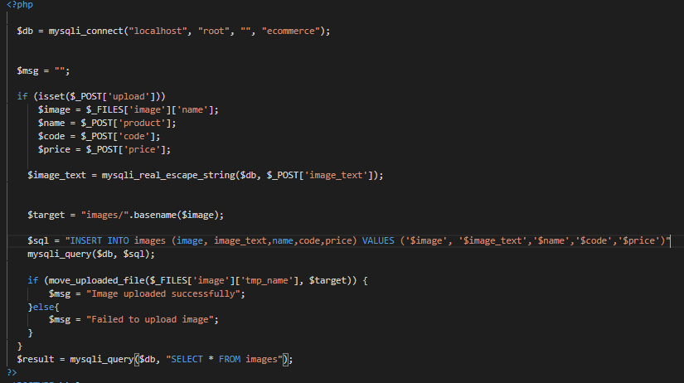

**Figure 23**

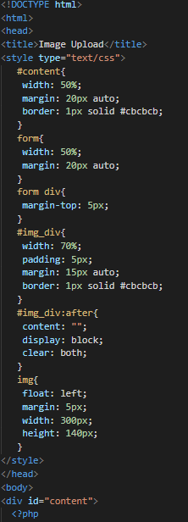

**Figure 24**

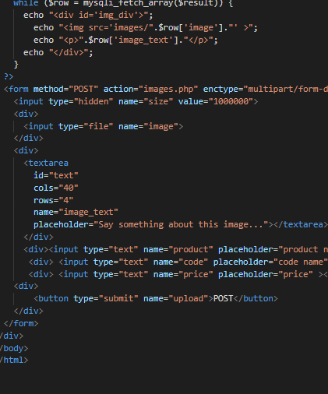

**Figure 25**

**Description**

Image upload module is used to upload the image of the product with all its details. Image upload is very important part as it has all the details of the product which are shown to the user.

**8. Contribution of team Members**

The whole project is made by the help of both the team members. We have help each other in their work. A good discussion is made between us before any implementation

.

**9. Bibliography**

<https://www.geeksforgeeks.org/>

<https://www.w3schools.com/>

<https://stackoverflow.com/>

<https://www.php.net/>